Name: ___________________________ Voyage of Trade & Discovery
Since the first century BCE, a network of trade routes had developed stretching from China to Europe and North Africa, a distance of 6500kms. This network became known as the Silk Road.
Silk originated from China and became a very coveted commodity, along with a range of spices. Without strong governments to protect these routes, traders became reluctant to use them.
A need to trade safely, a strong desire to spread Christianity ahead of Islam into Asia and a general thirst for world knowledge, pushed traders and explorers to look to the seas to venture further and move goods around.
China was viewed as a lucrative market. The first Europeans to venture into the Indian Ocean and arrive in China were the Portuguese, 1513, setting up trading posts on the way. The English and the Dutch soon followed.
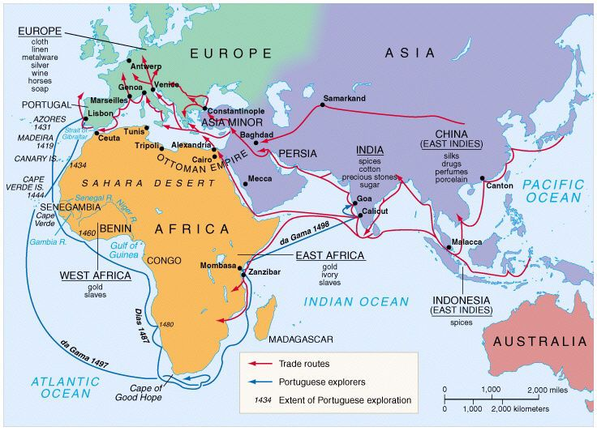

Many Europeans thought that China could be reached by sailing west from Europe. It is believed that Christopher Columbus was searching for such a route when he discovered the Americas in 1492.
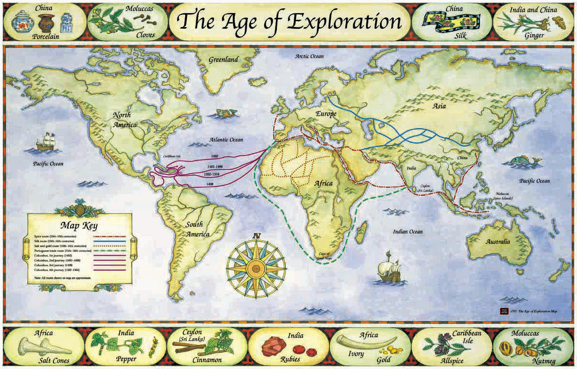

The Spanish and Portuguese then explored and conquered vast areas of the ‘New World’, establishing colonies in South, Central and North America. The British and the French also entered the Caribbean and North America.
Explorers also searched for ‘Terra Australis’ (South Land); the Dutch locating Tasmania and New Zealand; the British mapping Australia’s east coast.

As Europeans discovered new territories, they also encountered indigenous peoples and came into conflict with civilisations often not used to different technologies and diseases. Many indigenous peoples became enslaved to support the growing trade industries.

Trade and economics, competition and spheres of influence were the driving forces in exploration. By the eighteenth century much of the world had been reached by sea, creating new trade routes and many colonies, although the interiors of Africa and Australia remained a mystery to most Europeans.

